
Achievement Scale
Content Area: Biology | Grade Level: 10
Unit: Classification/Taxonomy
Students will understand:
- the classification system of organisms and the binomial nomenclature.
- how to read and interpret dichotomous keys, cladograms, and phylogenetic trees.
- the basic characteristics used to classify each Domain and Kingdom.
- how the anatomical and physiological adaptations of each Kingdom show adaptations to a niche and evolutionary relationships.
Score 4 - SWBAT:
A4. classify an organism referencing intermediate characteristics between taxonomic groups.
B4. explain the importance of the genus name compared the species name of an organism.
C4. construct a cladogram based on given characteristics of organisms.
D4. discuss evolutionary relationships between different taxonomic groups.
Score 3 - SWBAT:
A3. explain the similarities and differences between each taxonomic group.
B3. determine evolutionary relationships between organisms based on their genus and species name.
C3. determine evolutionary relationships based on their positions within a cladogram/phylogenetic tree.
D3. classify an organism in the correct Domain or Kingdom based on given characteristics of that organism.
Score 2 - SWBAT:
A2. list the levels of the classification system in the correct order.
B2. indentify genus and species name of an organism.
C2. identify an organism using a dichotomous key or cladogram.
D2. identify characteristics of each Domain and Kingdom
Score 1: With help (being given word banks, manipulated equations, retakes), the student demonstrates a partial understanding of the simpler details and processes that support the learning goal(s).
Score 0: Even with help, no success
Score 4 Example Assessment Items:  - Explain the importance of the genus name as compared to the species name of an organism. | Academic Vocabulary:  Classification  Taxonomy  Domain  Eukarya  Archaea  Bacteria  Kingdom  Phylum  Class  Order  Family  Genus  Species  Binomial Nomenclature  Dichotomous Key  Phylogentic tree  Cladogram  Derived characteristic
Score 3 Example Assessment Items:
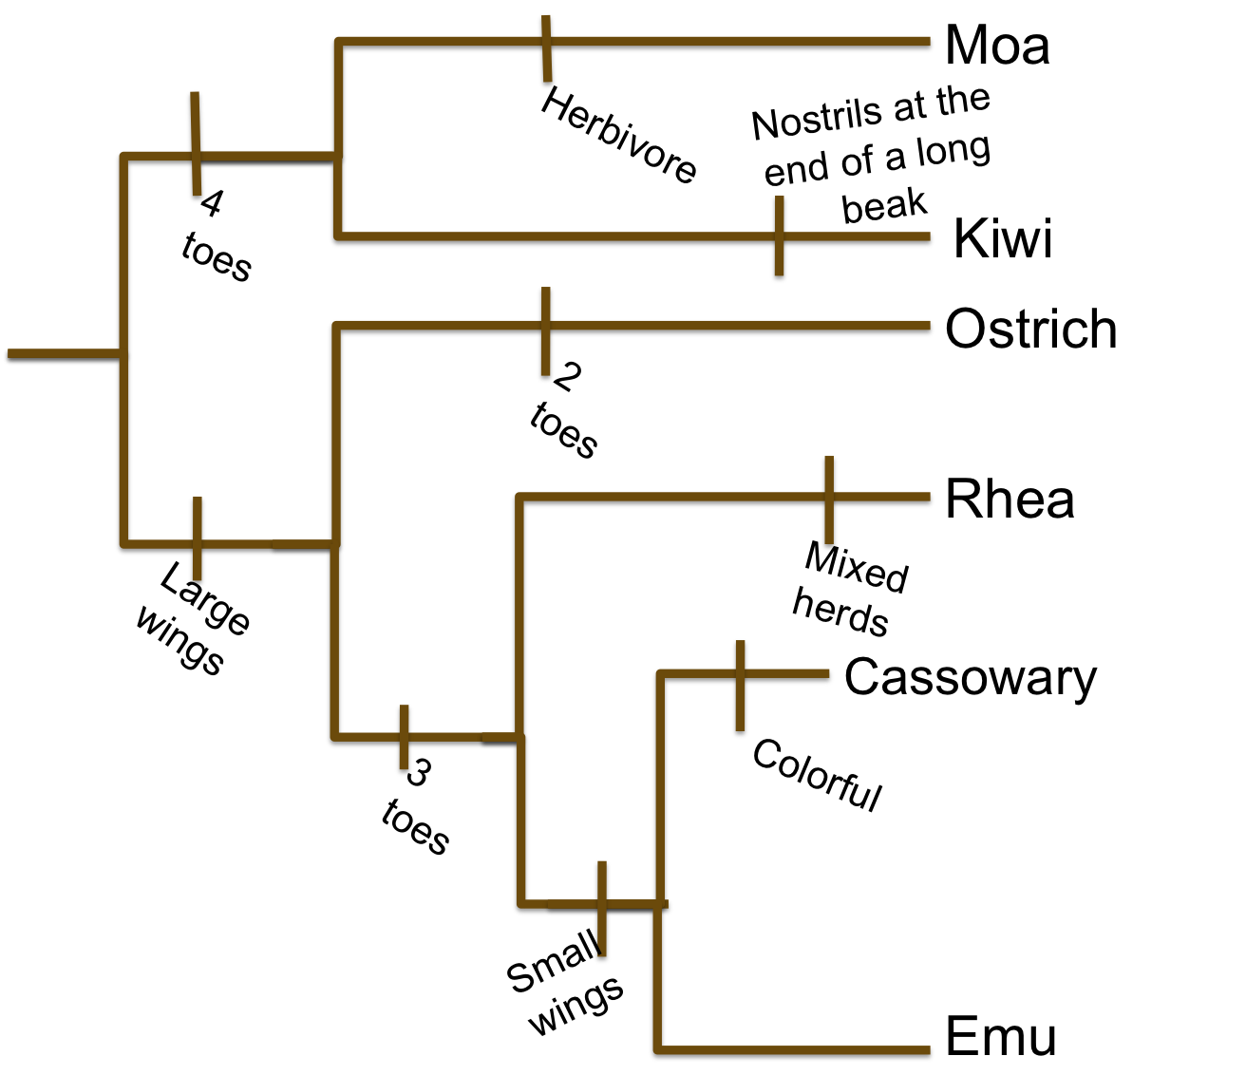
What organism is most closely related to the Emu?
What is the derived characteristic that separates the ostrich and the rhea?
Score 2 Example Assessment Items:
Which taxonomic level is more specific: order or genus?

District Mission:  Every student. Every day. | District Vision:  A promise of learning, dignity, and respect for all.

